# Informações do estudo

Referência: Cakir (1)

Grandeza: Rugosidade

Tipo: Ra

Material: AISI P20

Ferramenta: CNMG 120408 1

Número de experimentos: 27

Observações:  
Workpiece: diameter of 70mm and a length of 300mm  
Lathe: 5.5kW

# Unidades

Velocidade: m/min

Avanço: mm/rev

Profundidade de corte: mm

Rugosidade: μm

# Dados de teste

|  |  |  |  |
| --- | --- | --- | --- |
| Rugosidade | n | f | a |
| 0.82 | 160.0 | 0.12 | 1.0 |
| 2.58 | 120.0 | 0.22 | 1.0 |
| 1.45 | 160.0 | 0.18 | 2.0 |
| 1.63 | 120.0 | 0.18 | 2.0 |
| 0.87 | 120.0 | 0.12 | 1.0 |
| 1.39 | 160.0 | 0.18 | 1.0 |

# Dados de treino

|  |  |  |  |
| --- | --- | --- | --- |
| Rugosidade | n | f | a |
| 2.09 | 160.0 | 0.22 | 2.0 |
| 1.43 | 200.0 | 0.18 | 2.0 |
| 1.93 | 200.0 | 0.22 | 1.5 |
| 1.97 | 200.0 | 0.22 | 2.0 |
| 1.63 | 120.0 | 0.18 | 1.5 |
| 0.78 | 200.0 | 0.12 | 1.5 |
| 1.37 | 200.0 | 0.18 | 1.5 |
| 2.63 | 120.0 | 0.22 | 2.0 |
| 2.58 | 120.0 | 0.22 | 1.5 |
| 1.1 | 120.0 | 0.12 | 2.0 |
| 0.87 | 160.0 | 0.12 | 2.0 |
| 0.86 | 200.0 | 0.12 | 2.0 |
| 1.77 | 200.0 | 0.22 | 1.0 |
| 1.28 | 200.0 | 0.18 | 1.0 |
| 1.09 | 120.0 | 0.12 | 1.5 |
| 2.03 | 160.0 | 0.22 | 1.5 |
| 0.86 | 160.0 | 0.12 | 1.5 |
| 0.77 | 200.0 | 0.12 | 1.0 |
| 2.0 | 160.0 | 0.22 | 1.0 |
| 1.62 | 120.0 | 0.18 | 1.0 |
| 1.42 | 160.0 | 0.18 | 1.5 |

# RN

Número de neurônios: 25

Taxa de aprendizado: 1.000000e-01

Número de épocas: 562

2° camada: True

Função de ativação: relu

# Erros

**Dados de teste**

* Erro relativo médio: 6.66
* Coeficiente de correlação: 0.99
* Coeficiente de determinação: 0.98
* MSE: 0.01
* RMSE: 0.1

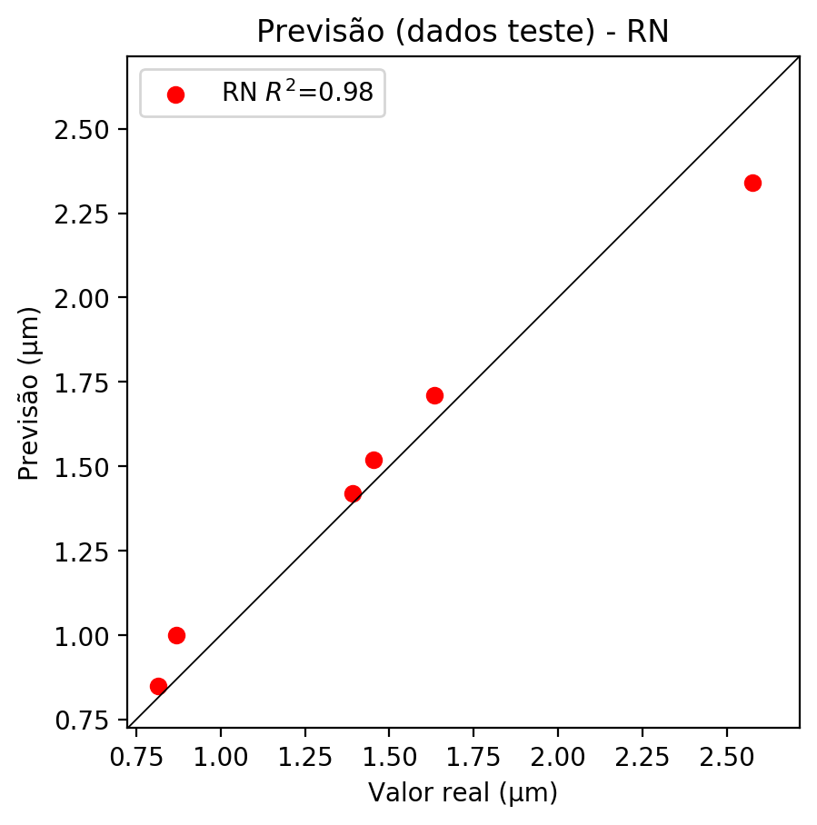

**Dados de treino**

* Erro relativo médio: 0.19
* Coeficiente de correlação: 1.0
* Coeficiente de determinação: 1.0
* MSE: 0.0
* RMSE: 0.0

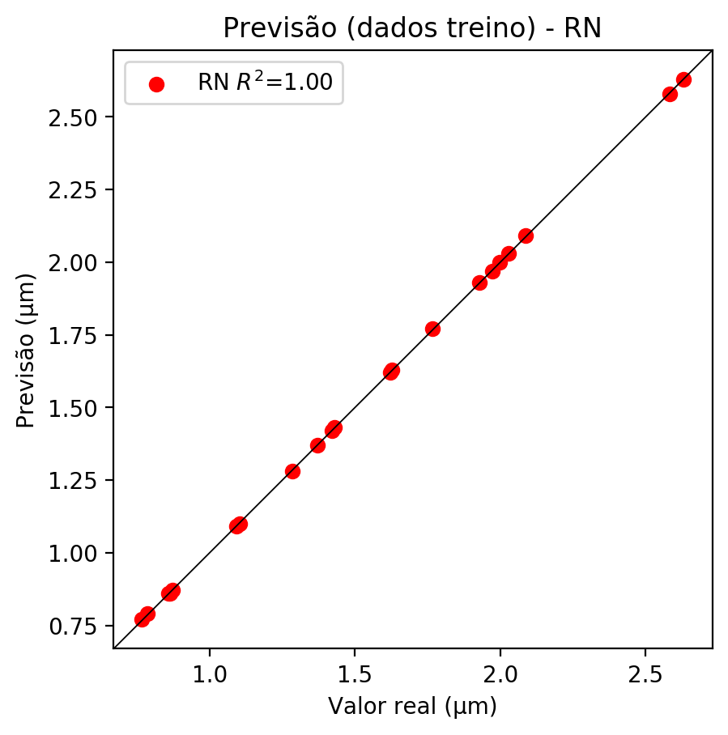

# Pesos

Pesos - camada oculta 1

[[-0.2784922 -0.0186557 -0.05803762 0.16786915 0.21155587 0.2580158  
 -0.21796186 0.15958515 0.13901283 -0.24818468 -0.23715976 -0.2889506  
 0.04153846 -0.15375406 -0.26605326 -0.20342515 0.4557472 -0.69504404  
 -0.1894847 -0.43592903 0.2026947 -0.85063803 0.48447326 -1.2402223  
 0.04642592]  
 [ 0.15396212 0.04136308 -0.02650652 -0.5764885 -1.2580888 0.03994693  
 0.2741468 0.13146822 -0.20003045 -0.13833258 1.7025974 -0.08706844  
 -0.13807264 0.25092292 -0.21578836 -0.27637503 -0.9416771 0.53351736  
 0.97058004 -0.11349934 -0.53555447 -0.81066996 -0.37184435 0.23713638  
 0.94832736]  
 [-0.5167954 0.20062268 -0.44531518 0.01052454 0.00709047 -0.20954143  
 0.26869464 0.13795725 0.09703629 0.38627493 0.5164158 0.01443109  
 -0.34128425 -0.21205229 -0.3224156 0.01202716 -0.13411334 -0.13469082  
 -0.32567024 -0.03930873 -0.08260667 0.15753055 -0.58611095 0.26618147  
 0.34005615]]

Bias - camada oculta

[-0.67340016 -0.38587356 -1.2206658 -0.6567874 0.39944872 -0.81829816  
 -0.6220067 -1.0244111 -0.8771305 -1.1697078 -0.04544879 -0.9961129  
 -0.22575502 -0.7581609 -0.76233554 -0.7169341 -0.39783815 -0.29253253  
 -0.32737616 -1.3572092 -0.12219576 -0.19962884 -0.35140195 -0.32424515  
 -0.19663313]

Pesos - camada oculta 2

[[-3.73656482e-01 -2.48875275e-01 3.61308277e-01 -4.37600553e-01  
 -4.59619105e-01 2.10850164e-01 5.41101396e-01 -5.73104680e-01  
 4.75751698e-01 -4.82190311e-01 1.83119252e-01 -3.76467019e-01  
 -4.85628694e-01 5.41685045e-01 4.44569468e-01 4.52118933e-01  
 -1.02307999e+00 4.20970321e-01 3.08628350e-01 -3.05519193e-01  
 -3.10944885e-01 -3.58960003e-01 2.27229297e-01 -5.42591691e-01  
 2.72019804e-01]  
 [-1.06215157e-01 2.45423838e-01 -2.07953423e-01 8.53955895e-02  
 -1.79128930e-01 -5.61990440e-01 -1.57626081e+00 -2.62378931e-01  
 -1.67480946e-01 2.89614916e-01 -9.39205229e-01 3.46166082e-02  
 1.74155787e-01 -9.58344281e-01 -6.91025376e-01 -2.03986745e-02  
 8.42039660e-02 -3.09418738e-01 -2.85625845e-01 2.77445745e-02  
 2.51609609e-02 -6.05449677e-01 -8.22367132e-01 1.53216168e-01  
 -2.77342111e-01]  
 [ 8.52496505e-01 1.23714738e-01 1.12682080e+00 3.51282656e-01  
 -9.84089170e-03 6.05317712e-01 -5.78698635e-01 4.60108072e-01  
 4.46409643e-01 3.22877586e-01 -3.22124571e-01 3.56917351e-01  
 3.44877213e-01 9.01041180e-02 -2.71371186e-01 -5.25363199e-02  
 5.02992272e-01 -4.78272676e-01 -8.94628882e-01 5.33907056e-01  
 5.61924994e-01 -5.63400030e-01 -6.00873351e-01 4.54618156e-01  
 -9.18569148e-01]  
 [ 3.27883542e-01 -8.39395523e-02 2.83038139e-01 -1.83647349e-01  
 -2.44898617e-01 -3.59327316e-01 -1.11044037e+00 6.27216548e-02  
 3.12457472e-01 2.38474816e-01 -4.26727891e-01 4.03090008e-02  
 8.78080726e-02 -7.27899611e-01 -3.21518511e-01 -1.32363439e-02  
 -4.31414843e-01 -9.44553912e-01 -5.14824450e-01 -1.43509090e-01  
 -1.03992239e-01 -9.33495343e-01 -7.91343927e-01 -8.67163986e-02  
 -1.07239139e+00]  
 [-4.34408486e-01 -6.17215097e-01 7.68419385e-01 -3.66662711e-01  
 -9.04178858e-01 -7.13735163e-01 -4.67622221e-01 -7.85035253e-01  
 3.19903493e-01 -3.76291692e-01 6.37760237e-02 -8.17486882e-01  
 -3.09167355e-01 4.24570143e-01 6.72515810e-01 4.21995729e-01  
 -1.11757362e+00 -4.53262419e-01 4.92585957e-01 -8.46603215e-01  
 -5.55367410e-01 -8.35330307e-01 -1.87482283e-01 -7.45463014e-01  
 -2.04257041e-01]  
 [-5.85543036e-01 5.38361788e-01 4.68465567e-01 -5.92437387e-01  
 4.22172278e-01 5.62866926e-01 3.17281097e-01 -5.69275796e-01  
 5.96163988e-01 8.92583072e-01 -2.95955241e-01 -7.63895810e-01  
 -4.67716247e-01 -2.98268199e-01 -3.32985222e-01 -4.04548615e-01  
 1.94633573e-01 -5.65896273e-01 -6.81954622e-01 -6.01893067e-01  
 -7.25130379e-01 -2.93561280e-01 -5.05352080e-01 -5.49235165e-01  
 -6.98372841e-01]  
 [-3.16572547e-01 -2.04445451e-01 2.72174448e-01 -2.74001420e-01  
 7.91905463e-01 -2.84252852e-01 2.45975569e-01 -4.91009116e-01  
 4.82372105e-01 -6.36296749e-01 2.76928067e-01 -3.98464292e-01  
 -8.63940537e-01 -6.30996823e-02 -2.55540818e-01 -4.02838796e-01  
 6.30004644e-01 -6.77419901e-01 -3.02269280e-01 -7.38564372e-01  
 -6.50070310e-01 -4.02258992e-01 1.77938044e-01 -5.39652228e-01  
 1.27980992e-01]  
 [-4.61069316e-01 -2.47957572e-01 6.94839835e-01 3.61850858e-01  
 4.34953153e-01 7.31858552e-01 5.10041058e-01 -5.82079172e-01  
 3.46650392e-01 -6.70136750e-01 3.94593477e-01 -3.35416973e-01  
 -3.17175031e-01 3.95590186e-01 -1.32327348e-01 2.16562927e-01  
 -3.35655898e-01 4.03530568e-01 6.39039874e-01 -4.44413900e-01  
 -6.73109293e-01 -3.63416821e-01 7.48981357e-01 -8.42082441e-01  
 4.68601704e-01]  
 [-4.12183672e-01 -4.42868292e-01 2.97920942e-01 9.71554741e-02  
 5.09862363e-01 -2.83849001e-01 -3.64853948e-01 -1.09660029e+00  
 -8.75987858e-02 -4.90310997e-01 5.51755250e-01 -8.59752536e-01  
 -9.91819263e-01 3.32056470e-02 -4.49552089e-01 -1.31863579e-01  
 1.92219824e-01 -4.11695480e-01 8.74086142e-01 -4.54429507e-01  
 -2.91698128e-01 -4.61412668e-01 -9.69051540e-01 -5.44101298e-01  
 3.81109893e-01]  
 [-8.39482367e-01 -2.54184544e-01 3.14188063e-01 -1.05105884e-01  
 -4.18088526e-01 -9.11704183e-01 -1.14970177e-01 -5.98527610e-01  
 2.30608568e-01 -4.12191033e-01 4.15732920e-01 -2.90888011e-01  
 -8.86648834e-01 2.93542236e-01 -7.54368901e-01 6.46013737e-01  
 -5.85409820e-01 1.12210989e-01 -6.45406246e-01 -6.14680469e-01  
 -4.30514544e-01 -5.60136557e-01 -6.27555907e-01 -1.82188869e-01  
 5.05195379e-01]  
 [-5.55385530e-01 -2.83752859e-01 7.47254074e-01 -2.84407824e-01  
 6.96576953e-01 1.04801379e-01 -4.70700376e-02 -1.24952054e+00  
 -3.01838890e-02 -1.38652515e+00 -9.27884817e-01 -4.27332222e-01  
 -1.17041802e+00 -6.46306515e-01 -8.31357181e-01 -8.22886288e-01  
 2.50777930e-01 -7.60408044e-01 -9.03908551e-01 -2.70359039e-01  
 -2.80731887e-01 -5.27942359e-01 -7.99017191e-01 -7.17645943e-01  
 -7.98277974e-01]  
 [-6.26509905e-01 -1.15191057e-01 2.89683342e-01 -4.02987063e-01  
 -1.74356893e-01 -6.21669471e-01 1.43893167e-01 -4.30934668e-01  
 3.62571359e-01 -5.69989681e-01 3.26311201e-01 -1.35708198e-01  
 -7.62678266e-01 -6.49415925e-02 -5.32067060e-01 5.48121274e-01  
 -2.42113933e-01 -8.49041343e-01 -4.12003279e-01 -4.71650779e-01  
 -2.79229790e-01 -6.73623502e-01 -9.24637735e-01 -4.51451600e-01  
 4.87745523e-01]  
 [-9.60616767e-01 -2.40748987e-01 -1.24898702e-01 2.06222564e-01  
 2.27823228e-01 -9.72020388e-01 -5.03575146e-01 -2.68199623e-01  
 3.65097374e-01 -3.57101828e-01 -3.43357593e-01 -6.14144027e-01  
 -7.05940843e-01 -6.73054636e-01 -4.27366793e-01 2.72894084e-01  
 1.61076844e-01 -6.64041162e-01 -6.00909412e-01 -1.45246750e-02  
 -1.38640314e-01 -7.79020548e-01 -7.87189066e-01 -4.42480534e-01  
 -7.66296625e-01]  
 [-8.04728866e-01 -2.75691003e-01 1.50838628e-01 -7.89387971e-02  
 4.55201328e-01 1.01302333e-01 3.13224673e-01 -1.02707303e+00  
 1.21655300e-01 -4.11902219e-01 2.83722103e-01 -6.11527205e-01  
 -3.15927178e-01 1.90149605e-01 -6.35499775e-01 -3.90656024e-01  
 -7.24095777e-02 6.31988764e-01 5.21208286e-01 -5.43829024e-01  
 -2.75644690e-01 -4.95090872e-01 4.17417735e-01 -9.98963356e-01  
 2.25061059e-01]  
 [-4.81009275e-01 -8.44188854e-02 5.03249466e-01 -4.72599477e-01  
 2.00758666e-01 4.35987562e-01 4.05242771e-01 -3.75604212e-01  
 6.85850143e-01 -6.40664577e-01 -7.05025554e-01 -7.24096894e-01  
 -9.25591052e-01 4.00048316e-01 -5.23425221e-01 -3.01566780e-01  
 3.76695883e-03 -4.92870390e-01 -2.98446208e-01 -9.03981149e-01  
 -4.32541549e-01 -7.22690761e-01 -3.06725144e-01 -3.96596730e-01  
 -3.61282796e-01]  
 [ 7.11390972e-01 -2.83007950e-01 1.42529562e-01 -2.14449242e-01  
 1.64576527e-02 -4.43645716e-01 -4.38929856e-01 5.38418710e-01  
 1.91916555e-01 2.47599348e-01 -3.78559947e-01 3.46925259e-01  
 7.90912092e-01 -1.21208906e-01 -2.58477479e-01 1.05096325e-01  
 -2.01332554e-01 -8.22205544e-01 -2.71664828e-01 -7.39075392e-02  
 7.85344020e-02 7.19002247e-01 -2.50646453e-02 -2.75371581e-01  
 -6.03795111e-01]  
 [ 2.53883123e-01 -5.61144054e-01 4.14659351e-01 -3.31192315e-01  
 -3.43558252e-01 -7.99891055e-01 -8.00521076e-01 2.31336936e-01  
 3.67021888e-01 6.54845119e-01 -9.29432511e-01 -3.32567930e-01  
 3.29946160e-01 2.97160804e-01 -6.61714196e-01 -3.25126834e-02  
 -2.95876265e-02 -8.91197443e-01 -5.02834976e-01 -4.53285635e-01  
 -2.88153052e-01 -7.01272666e-01 -1.35847282e+00 -3.65715086e-01  
 -1.26975155e+00]  
 [ 1.25384249e-03 -1.18978187e-01 -3.20971549e-01 1.10861212e-01  
 4.20735717e-01 -4.23556179e-01 -6.27752244e-01 -4.14743185e-01  
 -6.93676651e-01 -2.58759946e-01 -5.62125325e-01 -3.84788737e-02  
 -1.92683250e-01 -8.41327727e-01 -4.42148566e-01 -3.51636380e-01  
 1.15497783e-01 -4.15680379e-01 -6.52730823e-01 1.76309019e-01  
 4.47845876e-01 -8.77576232e-01 -2.08038211e-01 -2.61209607e-01  
 -9.37169135e-01]  
 [-5.33516593e-02 -3.80805671e-01 -5.52650690e-01 -5.45332730e-01  
 3.94811422e-01 -7.22522438e-01 -3.38066489e-01 -4.88821179e-01  
 -5.58555305e-01 -5.40277839e-01 -5.42370081e-01 1.27113998e-01  
 -3.29898074e-02 -1.31284571e+00 -8.10137987e-01 -2.47092284e-02  
 4.77842867e-01 -5.33380687e-01 -9.38944876e-01 4.93764430e-01  
 5.35570502e-01 5.74748337e-01 -4.84940976e-01 -4.31143671e-01  
 -4.42737132e-01]  
 [-8.24593604e-01 -5.11359870e-01 2.16243371e-01 -4.19574320e-01  
 -3.74396294e-01 -1.63721696e-01 -2.22741216e-01 -8.59984636e-01  
 4.88758773e-01 -4.77405399e-01 -2.11793110e-02 -5.72791874e-01  
 -7.67355502e-01 -1.46998733e-01 -6.41098559e-01 5.16038835e-01  
 -6.44228578e-01 -6.17219329e-01 -3.93167317e-01 -3.99003625e-01  
 -4.05794352e-01 -6.70457602e-01 5.09017706e-01 4.55223657e-02  
 -4.20363247e-02]  
 [-3.62750113e-01 4.48973566e-01 1.62919447e-01 1.76143870e-01  
 -8.82499591e-02 -3.84320706e-01 -2.99545437e-01 -9.44263577e-01  
 1.06788091e-01 -7.98504591e-01 5.56064099e-02 -1.15485620e+00  
 -8.80697906e-01 1.76354438e-01 -5.43491304e-01 3.39738727e-02  
 -6.00112319e-01 -1.97769678e-03 -8.67132843e-01 -1.08436215e+00  
 -6.08946681e-01 -6.55860960e-01 -5.05354702e-01 -3.92628461e-01  
 -3.69787186e-01]  
 [-8.49518180e-01 -1.22318882e-02 4.51226413e-01 2.30791166e-01  
 -2.36202329e-02 -8.24554741e-01 -3.97370100e-01 -6.49127841e-01  
 3.56144816e-01 -5.93933344e-01 1.68697797e-02 -1.02924597e+00  
 -9.33871031e-01 1.52707040e-01 -5.20151734e-01 3.06074888e-01  
 -8.48463595e-01 -6.64046586e-01 -6.54519796e-01 -6.43024027e-01  
 -6.38647020e-01 -3.01793337e-01 4.60713446e-01 -3.47471863e-01  
 -1.30201772e-01]  
 [-8.43027711e-01 -3.95121239e-02 6.79342568e-01 -4.40460831e-01  
 -2.51039565e-01 -3.31953242e-02 -5.48930228e-01 -5.78231037e-01  
 3.55724931e-01 -7.95214295e-01 -2.09518850e-01 -7.68981874e-01  
 -3.12270999e-01 -1.98200360e-01 -7.99927890e-01 4.26463671e-02  
 -4.79988188e-01 -6.05513096e-01 -2.23876238e-01 -4.54179436e-01  
 -4.86823738e-01 -8.44964147e-01 -4.24424745e-02 -4.97066498e-01  
 -8.78693461e-01]  
 [-5.27184010e-01 -8.26913118e-02 -2.51735330e-01 -1.93297789e-01  
 2.11257577e-01 -6.93329096e-01 -9.09270048e-01 -9.95161593e-01  
 -3.58411521e-02 -4.21225995e-01 -9.60527778e-01 6.49504811e-02  
 -5.50406754e-01 -1.07235789e+00 -5.53045034e-01 -3.39740276e-01  
 3.61646831e-01 -5.50661027e-01 -7.20920086e-01 2.40485474e-01  
 4.69101280e-01 -2.54334331e-01 -7.36023366e-01 -2.77024835e-01  
 -5.63902438e-01]  
 [ 8.50667134e-02 -3.60623926e-01 -3.70105714e-01 -2.82669872e-01  
 7.52942562e-01 -1.48651555e-01 -8.56979549e-01 -4.31644708e-01  
 -5.45771182e-01 -2.37317279e-01 -7.44840205e-01 -1.11979254e-01  
 -6.99279428e-01 -5.38648129e-01 -7.16933787e-01 -6.53626978e-01  
 4.42834496e-01 -7.65608072e-01 -2.77492762e-01 1.62309855e-01  
 6.19776368e-01 -7.34339297e-01 -6.20383024e-01 1.79269284e-01  
 -5.75512648e-01]]

Bias - camada oculta 2

[-0.81663173 0.02519181 0.1738363 -0.01659877 0.1565234 -0.28598922  
 -0.4290506 -1.2401569 -0.08212601 -1.1345506 -0.8045276 -0.7504744  
 -1.0346755 -0.2610196 -0.60053426 -0.21668652 -0.03418436 -0.6105851  
 -0.60053885 -0.5967174 -0.57651573 -0.6005454 -0.9148522 -0.13480839  
 -0.98121053]

Pesos - camada saída

[[-0.20741291 -0.06664593 -0.30431908 -0.10381562 0.33561087 0.2682646  
 0.06174326 -0.05693069 0.02908536 -0.38664597 0.42332336 -0.09835811  
 -0.34686604 -0.31478107 0.38519087 -0.02286611 0.27554128 0.47307178  
 0.1961311 -0.03860985 0.28462785 -0.2655308 -0.3288502 -0.06057562  
 -0.10150536]]

# Iterações

|  |  |  |  |  |  |  |
| --- | --- | --- | --- | --- | --- | --- |
| Média | Desvio | n | ln | 2° camada | Função | Épocas |
| -0.0997 | 0.0882 | 10 | 0.1 | False | relu | 38 |
| -0.1158 | 0.1698 | 17 | 0.1 | True | relu | 716 |
| -0.127 | 0.1646 | 7 | 0.01 | True | tanh | 130 |
| -0.2578 | 0.2273 | 19 | 0.001 | False | tanh | 282 |
| -0.2 | 0.2031 | 29 | 0.001 | False | relu | 469 |
| -0.1119 | 0.1278 | 88 | 0.1 | False | tanh | 926 |
| -0.1254 | 0.1468 | 95 | 0.0001 | True | relu | 984 |
| -0.1065 | 0.1172 | 10 | 0.01 | True | tanh | 865 |
| -0.7323 | 0.5658 | 58 | 0.001 | True | relu | 8 |
| -0.1292 | 0.1816 | 9 | 0.01 | False | tanh | 514 |
| -0.1451 | 0.1375 | 73 | 0.0001 | True | relu | 729 |
| -0.169 | 0.2097 | 22 | 0.001 | True | relu | 543 |
| -0.0789 | 0.098 | 25 | 0.1 | True | relu | 562 |
| -0.1557 | 0.1648 | 53 | 0.001 | False | relu | 498 |
| -0.0829 | 0.0948 | 83 | 0.01 | True | relu | 337 |
| -0.4615 | 0.3472 | 99 | 0.01 | False | tanh | 16 |
| -0.1105 | 0.0969 | 23 | 0.01 | False | relu | 472 |
| -0.1492 | 0.1439 | 24 | 0.001 | True | relu | 778 |
| -0.1123 | 0.1473 | 58 | 0.01 | True | tanh | 382 |
| -0.2614 | 0.1798 | 35 | 0.1 | False | tanh | 596 |

# RL

# Coeficientes

[ 0. -0.28755713 0.89061203 0.13175321]

# Erros

**Dados de teste**

* Erro relativo médio: 12.2
* Coeficiente de correlação: 0.93
* Coeficiente de determinação: 0.87
* MSE: 0.05
* RMSE: 0.22

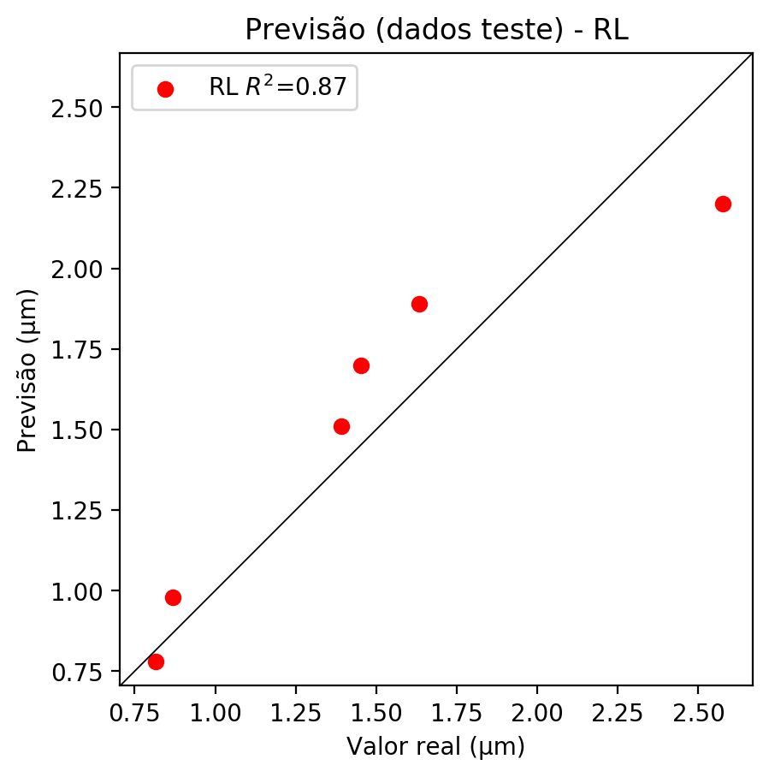

**Dados de treino**

* Erro relativo médio: 6.67
* Coeficiente de correlação: 0.98
* Coeficiente de determinação: 0.95
* MSE: 0.01
* RMSE: 0.1

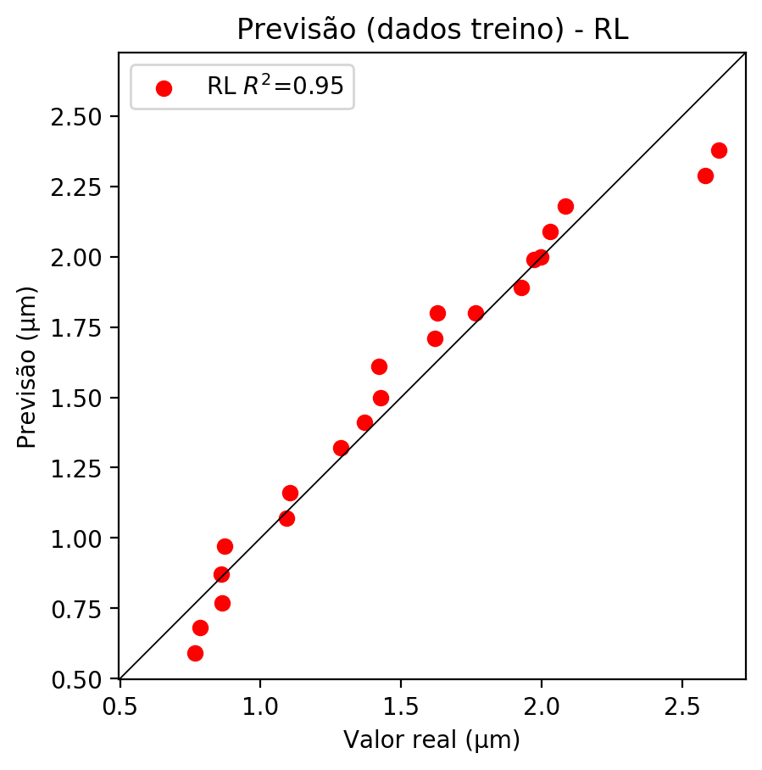

# RP2

# Coeficientes

[ 0. -0.2940593 0.95449663 0.12008282 0.16400438 -0.11442409  
 -0.01867223 0.20634509 0.01580245 -0.02271492]

# Erros

**Dados de teste**

* Erro relativo médio: 8.27
* Coeficiente de correlação: 0.97
* Coeficiente de determinação: 0.95
* MSE: 0.02
* RMSE: 0.14

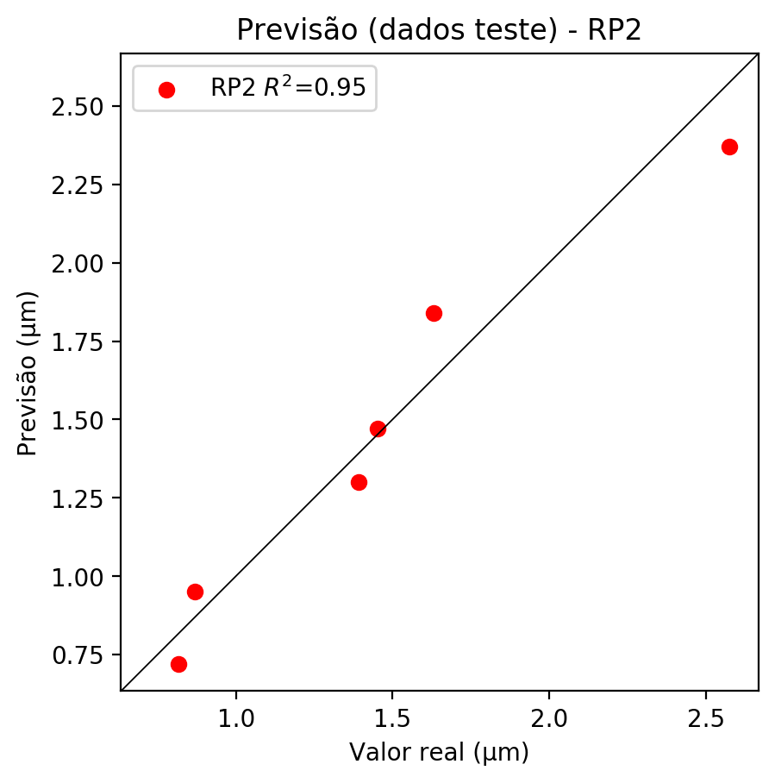

**Dados de treino**

* Erro relativo médio: 2.78
* Coeficiente de correlação: 1.0
* Coeficiente de determinação: 0.99
* MSE: 0.0
* RMSE: 0.0

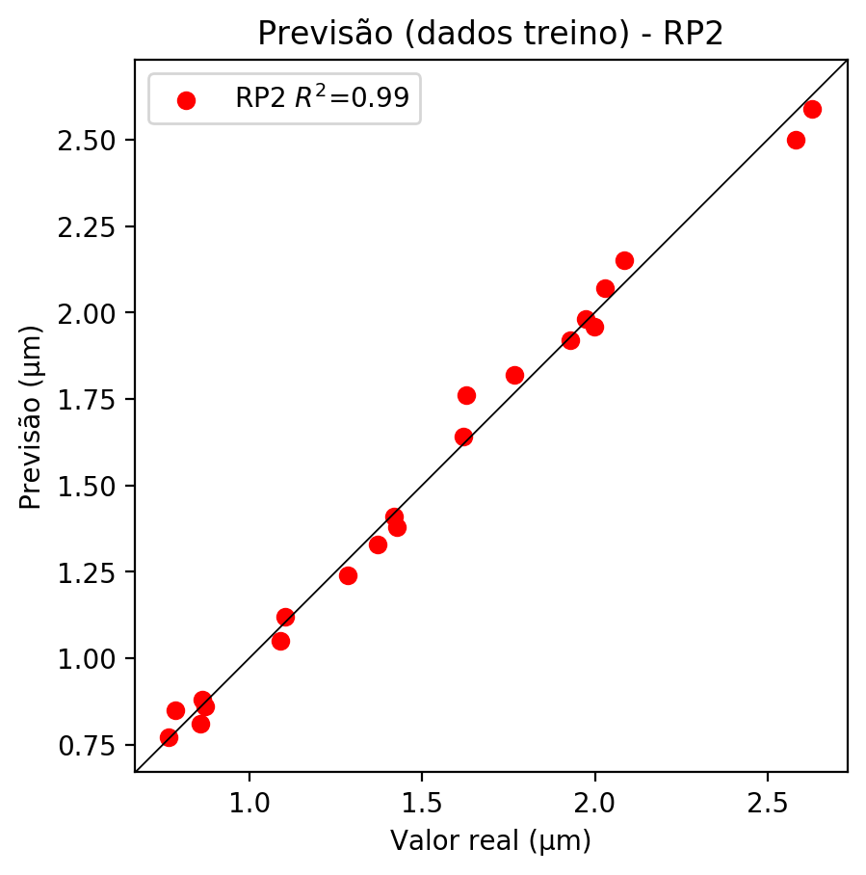

# RP3

# Coeficientes

[ 0. -0.05477447 0.29605597 -0.00106707 0.1469083 -0.12898647  
 0.02858077 0.26461543 0.05139706 0.00177121 -0.07911868 0.05835757  
 0.04866592 -0.13007931 -0.01418403 -0.01299205 0.4276364 0.00760527  
 -0.03545217 -0.00154132]

# Erros

**Dados de teste**

* Erro relativo médio: 10.57
* Coeficiente de correlação: 0.98
* Coeficiente de determinação: 0.97
* MSE: 0.02
* RMSE: 0.14

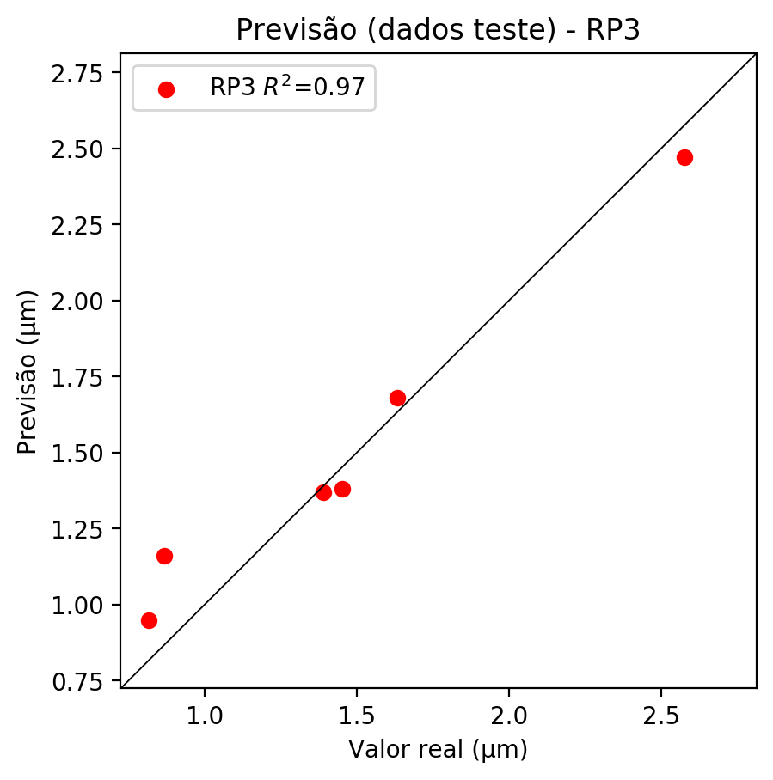

**Dados de treino**

* Erro relativo médio: 0.72
* Coeficiente de correlação: 1.0
* Coeficiente de determinação: 1.0
* MSE: 0.0
* RMSE: 0.0

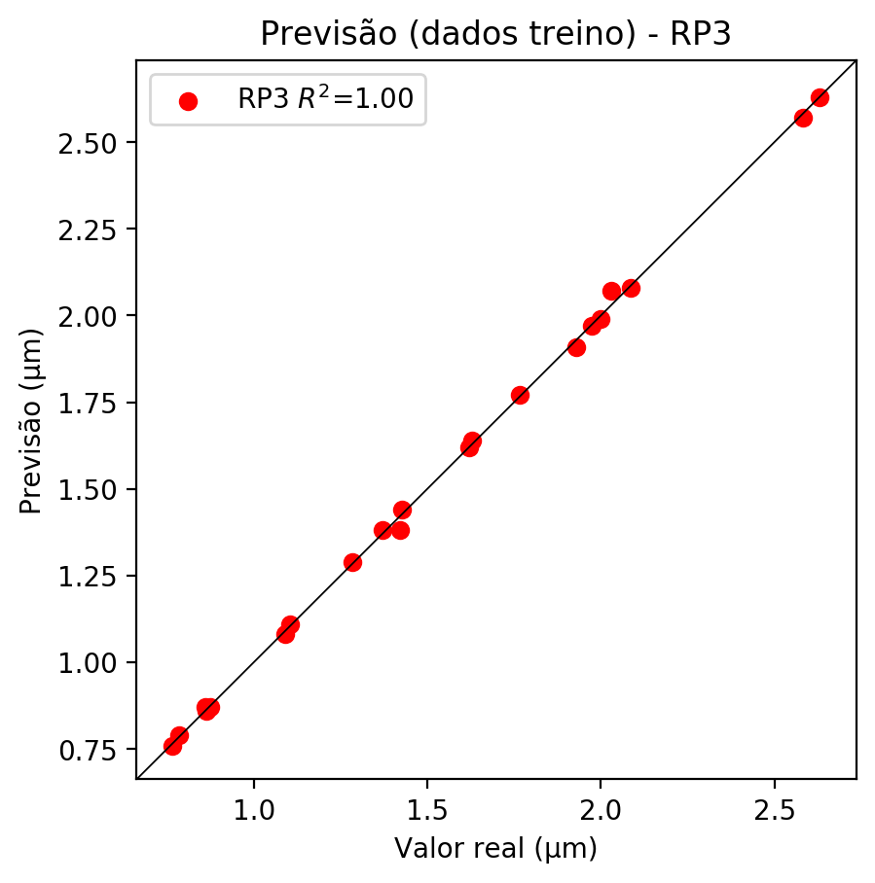

# RP4

# Coeficientes

[ 0. -0.05483832 0.29096177 0.00908599 0.02599839 -0.02805783  
 0.004322 0.08902959 0.00671193 0.01022031 -0.0792109 0.08700993  
 0.03155253 -0.13647609 0.02453325 -0.01229931 0.42027811 0.00176868  
 -0.00565081 0.0131242 0.03755323 -0.04052798 0.00624289 0.0777048  
 -0.01831553 -0.01889178 -0.02813969 0.00709356 -0.03399945 0.00624289  
 0.06286841 0.00764243 -0.00768218 0.00969501 0.01476267]

# Erros

**Dados de teste**

* Erro relativo médio: 5.54
* Coeficiente de correlação: 1.0
* Coeficiente de determinação: 1.0
* MSE: 0.01
* RMSE: 0.1

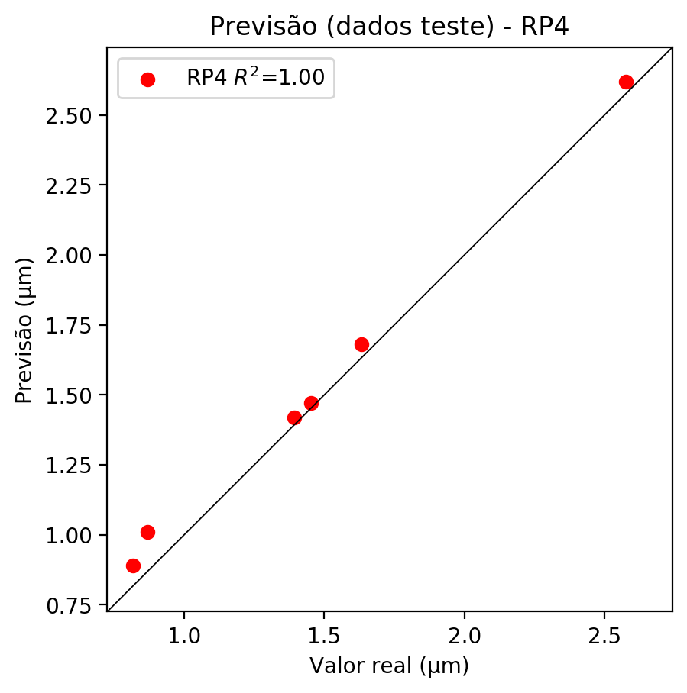

**Dados de treino**

* Erro relativo médio: 0.19
* Coeficiente de correlação: 1.0
* Coeficiente de determinação: 1.0
* MSE: 0.0
* RMSE: 0.0

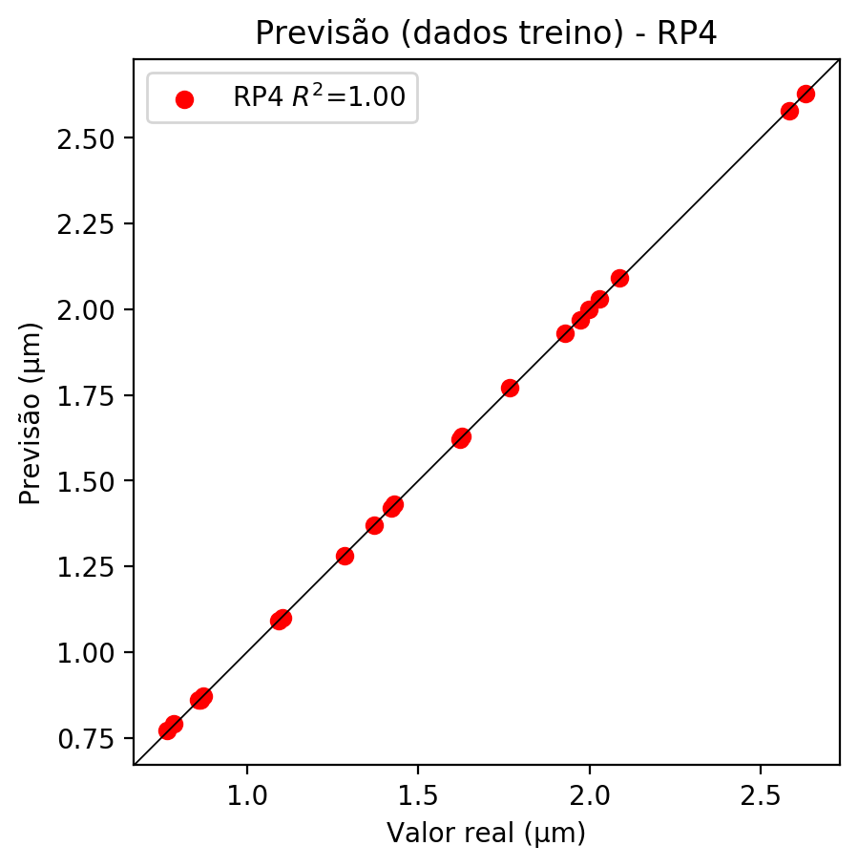

# Geral

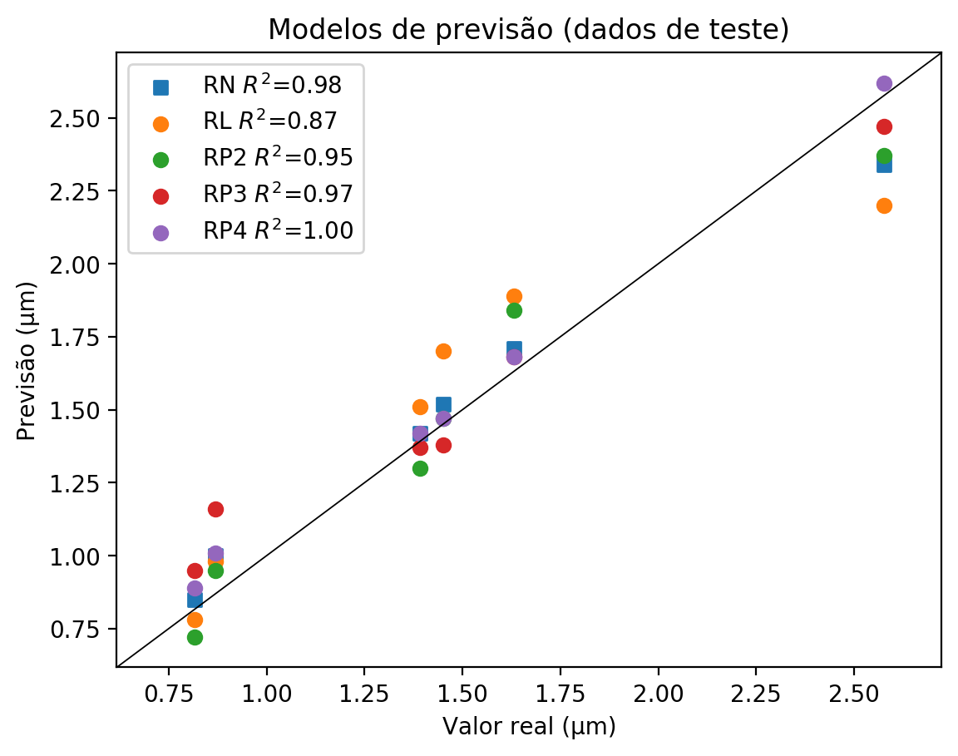

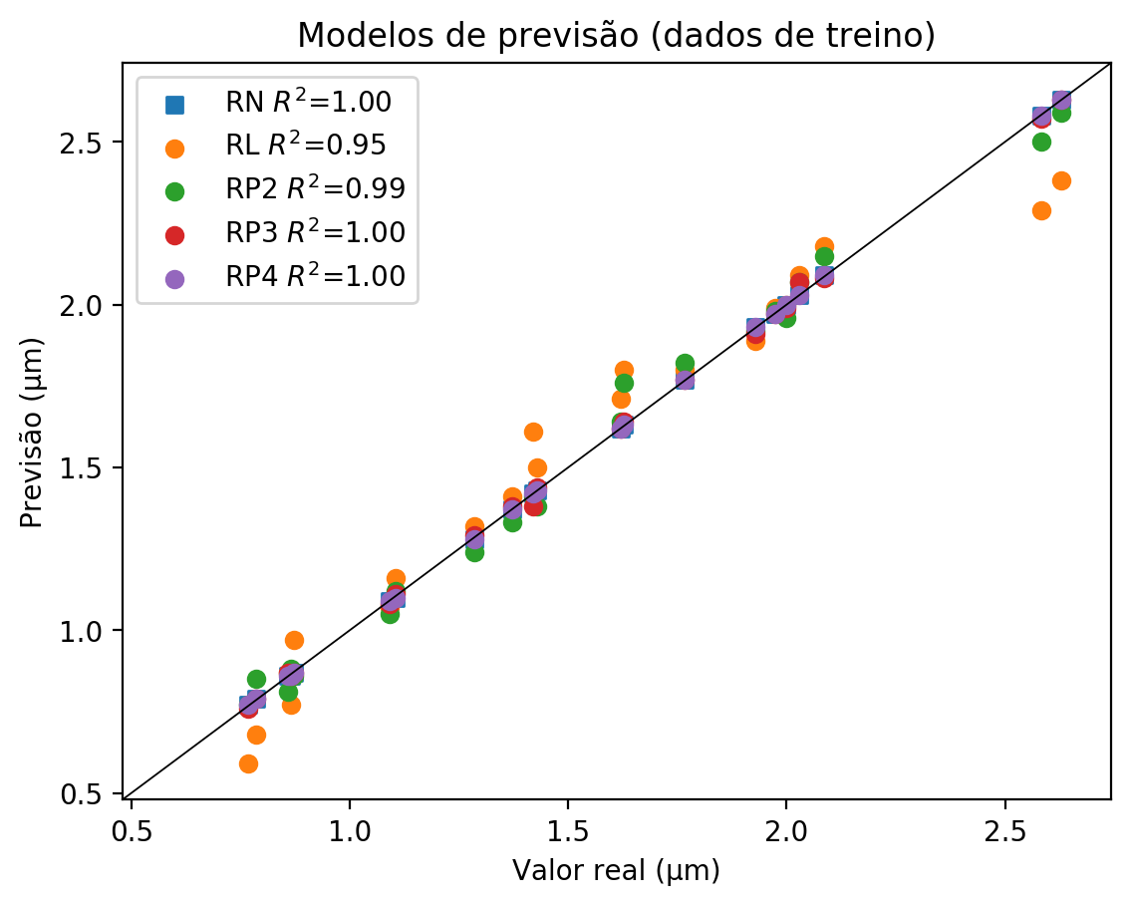

**Dados de teste**

|  |  |  |  |  |  |  |  |  |  |  |
| --- | --- | --- | --- | --- | --- | --- | --- | --- | --- | --- |
| Valor real | RN Previsto | RN Erro (%) | RL Previsto | RL Erro (%) | RP2 Previsto | RP2 Erro (%) | RP3 Previsto | RP3 Erro (%) | RP4 Previsto | RP4 Erro (%) |
| 0.82 | 0.85 | 4.17 | 0.78 | 4.41 | 0.72 | 11.76 | 0.95 | 16.42 | 0.89 | 9.07 |
| 2.58 | 2.34 | 9.16 | 2.2 | 14.6 | 2.37 | 8.0 | 2.47 | 4.11 | 2.62 | 1.71 |
| 1.45 | 1.52 | 4.68 | 1.7 | 17.08 | 1.47 | 1.24 | 1.38 | 4.96 | 1.47 | 1.24 |
| 1.63 | 1.71 | 4.78 | 1.89 | 15.81 | 1.84 | 12.75 | 1.68 | 2.94 | 1.68 | 2.94 |
| 0.87 | 1.0 | 15.07 | 0.98 | 12.77 | 0.95 | 9.32 | 1.16 | 33.49 | 1.01 | 16.23 |
| 1.39 | 1.42 | 2.08 | 1.51 | 8.55 | 1.3 | 6.54 | 1.37 | 1.51 | 1.42 | 2.08 |

**Dados de treino**

|  |  |  |  |  |  |  |  |  |  |  |
| --- | --- | --- | --- | --- | --- | --- | --- | --- | --- | --- |
| Valor real | RN Previsto | RN Erro (%) | RL Previsto | RL Erro (%) | RP2 Previsto | RP2 Erro (%) | RP3 Previsto | RP3 Erro (%) | RP4 Previsto | RP4 Erro (%) |
| 2.09 | 2.09 | 0.19 | 2.18 | 4.51 | 2.15 | 3.07 | 2.08 | 0.29 | 2.09 | 0.19 |
| 1.43 | 1.43 | 0.14 | 1.5 | 5.04 | 1.38 | 3.36 | 1.44 | 0.84 | 1.43 | 0.14 |
| 1.93 | 1.93 | 0.05 | 1.89 | 2.02 | 1.92 | 0.47 | 1.91 | 0.98 | 1.93 | 0.05 |
| 1.97 | 1.97 | 0.15 | 1.99 | 0.86 | 1.98 | 0.35 | 1.97 | 0.15 | 1.97 | 0.15 |
| 1.63 | 1.63 | 0.12 | 1.8 | 10.57 | 1.76 | 8.11 | 1.64 | 0.74 | 1.63 | 0.12 |
| 0.78 | 0.79 | 0.64 | 0.68 | 13.38 | 0.85 | 8.28 | 0.79 | 0.64 | 0.79 | 0.64 |
| 1.37 | 1.37 | 0.07 | 1.41 | 2.84 | 1.33 | 2.99 | 1.38 | 0.66 | 1.37 | 0.07 |
| 2.63 | 2.63 | 0.04 | 2.38 | 9.47 | 2.59 | 1.48 | 2.63 | 0.04 | 2.63 | 0.04 |
| 2.58 | 2.58 | 0.08 | 2.29 | 11.31 | 2.5 | 3.18 | 2.57 | 0.46 | 2.58 | 0.08 |
| 1.1 | 1.1 | 0.36 | 1.16 | 5.07 | 1.12 | 1.45 | 1.11 | 0.54 | 1.1 | 0.36 |
| 0.87 | 0.87 | 0.34 | 0.97 | 11.11 | 0.86 | 1.49 | 0.87 | 0.34 | 0.87 | 0.34 |
| 0.86 | 0.86 | 0.46 | 0.77 | 10.88 | 0.88 | 1.85 | 0.86 | 0.46 | 0.86 | 0.46 |
| 1.77 | 1.77 | 0.23 | 1.8 | 1.93 | 1.82 | 3.06 | 1.77 | 0.23 | 1.77 | 0.23 |
| 1.28 | 1.28 | 0.31 | 1.32 | 2.8 | 1.24 | 3.43 | 1.29 | 0.47 | 1.28 | 0.31 |
| 1.09 | 1.09 | 0.09 | 1.07 | 1.92 | 1.05 | 3.76 | 1.08 | 1.01 | 1.09 | 0.09 |
| 2.03 | 2.03 | 0.05 | 2.09 | 3.01 | 2.07 | 2.02 | 2.07 | 2.02 | 2.03 | 0.05 |
| 0.86 | 0.86 | 0.12 | 0.87 | 1.28 | 0.81 | 5.7 | 0.87 | 1.28 | 0.86 | 0.12 |
| 0.77 | 0.77 | 0.52 | 0.59 | 22.98 | 0.77 | 0.52 | 0.76 | 0.78 | 0.77 | 0.52 |
| 2.0 | 2.0 | 0.1 | 2.0 | 0.1 | 1.96 | 1.9 | 1.99 | 0.4 | 2.0 | 0.1 |
| 1.62 | 1.62 | 0.0 | 1.71 | 5.56 | 1.64 | 1.23 | 1.62 | 0.0 | 1.62 | 0.0 |
| 1.42 | 1.42 | 0.0 | 1.61 | 13.38 | 1.41 | 0.7 | 1.38 | 2.82 | 1.42 | 0.0 |